

Practical No. : 2
Aim -
Use var, let, const, and demonstrate basic features like template literals and destructuring; build a billing calculator with user input.
Software/Tools Required –
VSCode, Chrome, HTML5, CSS3, Javascript (ES6)
Experiment Program Code –
index.html
<!DOCTYPE html>
<html lang="en">
<head>
<meta charset="UTF-8">
<title>Billing Calculator</title>
</head>

<body>

<div class="container">
<h1>🧾 Billing Calculator</h1>

<label>Customer Name</label>
<input type="text" id="name" placeholder="Enter customer name"> <br> <br>

<label>Product Name</label>
<input type="text" id="product" placeholder="Enter product"> <br> <br>

<label>Price per Item (₹)</label>
<input type="number" id="price" placeholder="Enter price"> <br> <br>

<label>Quantity</label>
<input type="number" id="quantity" placeholder="Enter quantity"> <br> <br>

<button onclick="calculateBill()">Generate Bill</button>

<div id="output"></div>
</div>

<script src="script.js"></script>
</body>
</html>
script.js
function calculateBill() {

const customerName = document.getElementById("name").value.trim();
const product = document.getElementById("product").value.trim();
const price = parseFloat(document.getElementById("price").value);
const quantity = parseInt(document.getElementById("quantity").value);

if (
customerName === "" ||
product === "" ||
isNaN(price) ||
isNaN(quantity) ||
price <= 0 ||
quantity <= 0
) {
document.getElementById("output").style.display = "block";
document.getElementById("output").innerHTML = `
<h2>⚠️ Invalid Input</h2>
<p>Please fill all fields correctly.</p>
`;
return;
}

const GST = 0.18;

const subtotal = price * quantity;
const gstAmount = subtotal * GST;
const total = subtotal + gstAmount;

const bill = {
customerName,
product,
price,
quantity,
subtotal,
gstAmount,
total
};

const {
customerName: name,
product: item,
price: itemPrice,
quantity: qty,
subtotal: sub,
gstAmount: gst,
total: finalAmount
} = bill;

document.getElementById("output").style.display = "block";

document.getElementById("output").innerHTML = `
<h2>🧾 Billing Details</h2>

<p><b>👤 Customer:</b> ${name}</p>
<p><b>📦 Product:</b> ${item}</p>
<p><b>💵 Price per Item:</b> ₹${itemPrice.toFixed(2)}</p>
<p><b>🔢 Quantity:</b> ${qty}</p>

<hr>

<p><b>💰 Subtotal:</b> ₹${sub.toFixed(2)}</p>
<p><b>🧾 GST (18%):</b> ₹${gst.toFixed(2)}</p>

<hr>

<p class="total">💳 Total Amount: ₹${finalAmount.toFixed(2)}</p>
`;

console.log("===== BILL =====");
console.log("Customer :", name);
console.log("Product :", item);
console.log("Price :", itemPrice);
console.log("Quantity :", qty);
console.log("Subtotal :", sub.toFixed(2));
console.log("GST :", gst.toFixed(2));
console.log("Total :", finalAmount.toFixed(2));
}

Output -
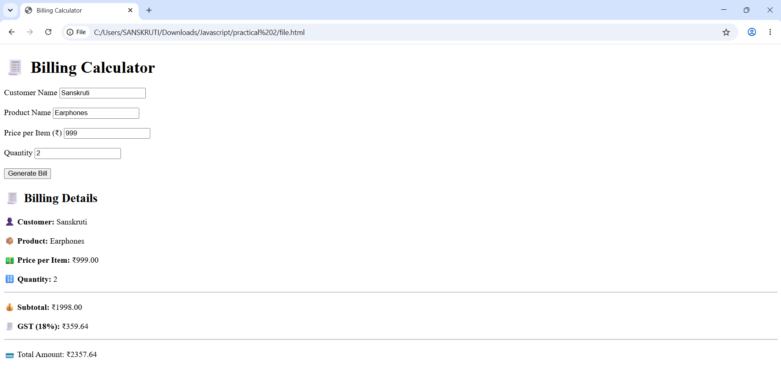
Case Study Title –
Develop the webpage for an online shopping website with using HTML, CSS and HTML tags and calculate the bill.

Case Study Program Code –

index.html
<!DOCTYPE html>
<html lang="en">
<head>
<meta charset="UTF-8">
<meta name="viewport" content="width=device-width, initial-scale=1.0">
<title>Order Invoice</title>
<link rel="preconnect" href="https://fonts.googleapis.com">
<link rel="preconnect" href="https://fonts.gstatic.com" crossorigin>
<link href="https://fonts.googleapis.com/css2?family=Inter:wght@400;500;600;700;800&display=swap" rel="stylesheet">
<link rel="stylesheet" href="styles.css">
</head>
<body>
<div class="page-wrap">
<div class="app-shell">
<header class="topbar">
<div class="brand-block">
<div class="brand-mark">N</div>
<div>
<p class="brand-name">NovaCart</p>
<p class="brand-sub">order details</p>
</div>
</div>
<div class="topbar-badge">GST 18% � cart discount available</div>
</header>

<main class="layout">
<section class="entry-panel">
<div class="panel-card">
<div class="section-head">
<div>
<p class="mini-label">Customer</p>
<h1>Invoice Builder</h1>
</div>
</div>

<div class="field-grid two-col">
<div class="field">
<label for="name">Customer Name</label>
<input type="text" id="name" placeholder="Enter customer name">
</div>
<div class="field">
<label for="city">City</label>
<input type="text" id="city" placeholder="Enter city">
</div>
</div>
</div>

<div class="panel-card">
<div class="section-head compact">
<div>
<p class="mini-label">Add Item</p>
<h2>Enter product</h2>
</div>
<button type="button" class="ghost-btn" onclick="addItem()">Add Item</button>
</div>

<div class="field-grid three-col">
<div class="field">
<label for="product">Product</label>
<input type="text" id="product" placeholder="Enter product name">
</div>
<div class="field">
<label for="price">Price (Rs)</label>
<input type="number" id="price" placeholder="Enter price">
</div>
<div class="field">
<label for="quantity">Quantity</label>
<input type="number" id="quantity" placeholder="Enter quantity">
</div>
</div>
</div>

<div class="panel-card cart-preview">
<div class="section-head compact">
<div>
<p class="mini-label">Cart</p>
<h2>Selected items</h2>
</div>
<button type="button" class="ghost-btn" onclick="clearCart()">Clear Cart</button>
</div>
<div id="cartItems" class="cart-items"></div>
</div>
</section>

<aside class="invoice-panel">
<div class="panel-card invoice-card" id="output">
<div class="empty-state">
<h2>Invoice preview</h2>
<p>Add items and generate the final bill.</p>
</div>
</div>
<button class="main-btn" onclick="calculateBill()">Generate Invoice</button>
</aside>
</main>
</div>
</div>

<script src="script.js"></script>
</body>

<footer class="footer">
<p>© 2026 | Online Shopping Store</p>
<p class="credits">Developed by Sanskruti Gorle • PRN: 24070521025</p>
</footer>
</html>

syle.css

:root {
--bg: #f1f3f6;
--card: #ffffff;
--line: #e3e7ee;
--text: #1f2937;
--muted: #6b7280;
--blue: #2874f0;
--blue-dark: #1859c9;
--green: #1f8f4d;
--shadow: 0 12px 30px rgba(15, 23, 42, 0.06);
--radius-lg: 20px;
--radius-md: 14px;
}

* {
box-sizing: border-box;
}

body {
margin: 0;
font-family: "Inter", sans-serif;
background: var(--bg);
color: var(--text);
}

button,
input {
font: inherit;
}

.page-wrap {
min-height: 100vh;
padding: 24px 16px;
}

.app-shell {
width: min(1180px, 100%);
margin: 0 auto;
}

.topbar {
display: flex;
align-items: center;
justify-content: space-between;
gap: 16px;
margin-bottom: 20px;
padding: 18px 22px;
background: var(--card);
border: 1px solid var(--line);
border-radius: var(--radius-lg);
box-shadow: var(--shadow);
}

.brand-block {
display: flex;
align-items: center;
gap: 12px;
}

.brand-mark {
width: 42px;
height: 42px;
display: grid;
place-items: center;
border-radius: 12px;
background: linear-gradient(135deg, var(--blue), #4ea1ff);
color: #fff;
font-weight: 800;
}

.brand-name,
.brand-sub,
.mini-label {
margin: 0;
}

.brand-name,
h1,
h2,
.amount-total {
font-weight: 800;
}

.brand-sub,
.mini-label,
.field label,
.cart-line p,
.meta-row p,
.invoice-row span,
.empty-state p,
.topbar-badge {
color: var(--muted);
}

.brand-sub,
.mini-label {
font-size: 0.78rem;
text-transform: uppercase;
letter-spacing: 0.08em;
}

.topbar-badge {
padding: 10px 14px;
border-radius: 999px;
background: #eef4ff;
font-weight: 700;
}

.layout {
display: grid;
grid-template-columns: 1.08fr 0.92fr;
gap: 20px;
align-items: start;
}

.entry-panel,
.invoice-panel {
display: grid;
gap: 18px;
}

.panel-card {
background: var(--card);
border: 1px solid var(--line);
border-radius: var(--radius-lg);
box-shadow: var(--shadow);
padding: 22px;
}

.section-head,
.cart-line,
.invoice-head,
.invoice-row,
.invoice-total,
.meta-grid {
display: flex;
justify-content: space-between;
gap: 12px;
}

.section-head,
.invoice-head,
.invoice-total {
align-items: center;
}

.section-head.compact {
margin-bottom: 16px;
}

h1 {
margin: 4px 0 0;
font-size: 1.6rem;
}

h2 {
margin: 4px 0 0;
font-size: 1.15rem;
}

.field-grid {
display: grid;
gap: 14px;
}

.two-col {
grid-template-columns: repeat(2, minmax(0, 1fr));
}

.three-col {
grid-template-columns: 1.5fr 1fr 1fr;
}

.field {
display: grid;
gap: 8px;
}

.field label {
font-size: 0.92rem;
font-weight: 700;
}

input {
width: 100%;
padding: 13px 14px;
border: 1px solid var(--line);
border-radius: 12px;
background: #fbfcfe;
color: var(--text);
}

input:focus {
outline: 2px solid rgba(40, 116, 240, 0.18);
border-color: rgba(40, 116, 240, 0.45);
}

.ghost-btn,
.main-btn,
.action-btn {
border: 0;
cursor: pointer;
font-weight: 700;
}

.ghost-btn,
.action-btn {
padding: 10px 14px;
border-radius: 12px;
}

.ghost-btn {
background: #f2f4f8;
color: var(--text);
}

.main-btn {
width: 100%;
padding: 16px;
border-radius: 16px;
background: linear-gradient(135deg, var(--blue), #4c97ff);
color: #fff;
box-shadow: 0 14px 28px rgba(40, 116, 240, 0.2);
}

.cart-items {
display: grid;
gap: 12px;
}

.cart-line {
align-items: center;
padding: 14px;
border: 1px solid var(--line);
border-radius: 14px;
background: #fafbfd;
}

.cart-line p,
.meta-row p {
margin: 4px 0 0;
}

.line-actions {
display: flex;
gap: 8px;
}

.action-btn {
background: #fff1f2;
color: #c7374c;
}

.invoice-card {
min-height: 420px;
}

.empty-state {
min-height: 300px;
display: grid;
place-items: center;
text-align: center;
}

.invoice-head {
margin-bottom: 18px;
}

.invoice-badge {
padding: 9px 12px;
border-radius: 999px;
background: #eefbf3;
color: var(--green);
font-weight: 700;
}

.meta-grid {
margin: 16px 0;
padding: 16px;
border-radius: 14px;
background: #f8fafc;
}

.meta-row p {
color: var(--muted);
}

.meta-row strong,
.invoice-row strong,
.invoice-total span,
.amount-total,
.cart-line strong {
color: var(--text);
}

.invoice-items,
.invoice-summary {
display: grid;
gap: 12px;
}

.invoice-items {
border-top: 1px solid var(--line);
border-bottom: 1px solid var(--line);
padding: 14px 0;
margin: 18px 0;
}

.invoice-row {
align-items: center;
}

.invoice-total {
margin-top: 18px;
padding-top: 18px;
border-top: 1px dashed #cdd5df;
}

.amount-total {
font-size: 1.6rem;
color: var(--blue-dark);
}

.invoice-note {
margin-top: 18px;
padding: 14px;
border-radius: 14px;
background: #f5f9ff;
color: var(--muted);
}

.bill-error,
.empty-cart {
padding: 16px;
border-radius: 14px;
background: #fff7ed;
color: #9a5a18;
}

@media (max-width: 920px) {
.layout,
.two-col,
.three-col,
.meta-grid {
grid-template-columns: 1fr;
display: grid;
}
}

@media (max-width: 700px) {
.topbar,
.section-head,
.cart-line,
.invoice-head,
.invoice-row,
.invoice-total {
flex-direction: column;
align-items: flex-start;
}

.panel-card {
padding: 18px;
}
}

.footer{
width: 500px;
margin: 20px auto 40px;
padding: 15px 20px;
background: white;
border-radius: 10px;
box-shadow: 0 5px 15px rgba(0,0,0,0.15);
text-align: center;
border-top: 4px solid #1e88e5;
}

.footer p{
margin: 0;
font-size: 16px;
color: #1e3c72;
font-weight: 600;
}

.footer span{
display: block;
margin-top: 5px;
font-size: 14px;
color: #666;
}

script.js

let cart = [];

function formatCurrency(amount) {
return `Rs ${amount.toFixed(2)}`;
}

function resetItemFields() {
document.getElementById("product").value = "";
document.getElementById("price").value = "";
document.getElementById("quantity").value = "";
}

function renderCart() {
const cartItems = document.getElementById("cartItems");

if (cart.length === 0) {
cartItems.innerHTML = '<div class="empty-cart">No items added yet.</div>';
return;
}

cartItems.innerHTML = cart.map((item, index) => `
<div class="cart-line">
<div>
<strong>${item.product}</strong>
<p>${item.quantity} x ${formatCurrency(item.price)}</p>
</div>
<div class="line-actions">
<strong>${formatCurrency(item.subtotal)}</strong>
<button type="button" class="action-btn" onclick="removeItem(${index})">Remove</button>
</div>
</div>
`).join("");
}

function addItem() {
const product = document.getElementById("product").value.trim();
const price = parseFloat(document.getElementById("price").value);
const quantity = parseInt(document.getElementById("quantity").value);

if (
product === "" ||
isNaN(price) ||
isNaN(quantity) ||
price <= 0 ||
quantity <= 0
) {
document.getElementById("output").innerHTML = `
<div class="bill-error">
<h2>Invalid item details</h2>
<p>Please enter product name, price, and quantity correctly.</p>
</div>
`;
return;
}

const subtotal = price * quantity;

const item = {
product,
price,
quantity,
subtotal
};

cart.push(item);
resetItemFields();
renderCart();
}

function removeItem(index) {
cart.splice(index, 1);
renderCart();
}

function clearCart() {
cart = [];
renderCart();
document.getElementById("output").innerHTML = `
<div class="empty-state">
<h2>Invoice preview</h2>
<p>Add items and generate the final bill.</p>
</div>
`;
}

function calculateBill() {
const customerName = document.getElementById("name").value.trim();
const city = document.getElementById("city").value.trim();

if (customerName === "" || city === "" || cart.length === 0) {
document.getElementById("output").innerHTML = `
<div class="bill-error">
<h2>Invalid input</h2>
<p>Please enter customer details and add at least one item.</p>
</div>
`;
return;
}

const GST = 0.18;
const subtotal = cart.reduce((sum, item) => sum + item.subtotal, 0);
const totalQuantity = cart.reduce((sum, item) => sum + item.quantity, 0);
const DISCOUNT_RATE = totalQuantity >= 3 ? 0.12 : 0.05;
const discountAmount = subtotal * DISCOUNT_RATE;
const discountedSubtotal = subtotal - discountAmount;
const gstAmount = discountedSubtotal * GST;
const total = discountedSubtotal + gstAmount;

const bill = {
customerName,
city,
items: cart,
subtotal,
discountAmount,
discountedSubtotal,
gstAmount,
total
};

const {
customerName: name,
city: customerCity,
items,
subtotal: sub,
discountAmount: discount,
discountedSubtotal: afterDiscount,
gstAmount: gst,
total: finalAmount
} = bill;

const itemRows = items.map((item) => `
<div class="invoice-row">
<span>${item.product} (${item.quantity} x ${formatCurrency(item.price)})</span>
<strong>${formatCurrency(item.subtotal)}</strong>
</div>
`).join("");

document.getElementById("output").innerHTML = `
<div class="invoice-head">
<div>
<p class="mini-label">Tax Invoice</p>
<h2>Order Summary</h2>
</div>
<div class="invoice-badge">Order Confirmed</div>
</div>

<div class="meta-grid">
<div class="meta-row">
<p>Customer</p>
<strong>${name}</strong>
</div>
<div class="meta-row">
<p>City</p>
<strong>${customerCity}</strong>
</div>
<div class="meta-row">
<p>Items</p>
<strong>${items.length}</strong>
</div>
</div>

<div class="invoice-items">
${itemRows}
</div>

<div class="invoice-summary">
<div class="invoice-row">
<span>Subtotal</span>
<strong>${formatCurrency(sub)}</strong>
</div>
<div class="invoice-row">
<span>Discount (${(DISCOUNT_RATE * 100).toFixed(0)}%)</span>
<strong>- ${formatCurrency(discount)}</strong>
</div>
<div class="invoice-row">
<span>Amount after Discount</span>
<strong>${formatCurrency(afterDiscount)}</strong>
</div>
<div class="invoice-row">
<span>GST (18%)</span>
<strong>${formatCurrency(gst)}</strong>
</div>
</div>

<div class="invoice-total">
<span>Total Amount Payable</span>
<strong class="amount-total">${formatCurrency(finalAmount)}</strong>
</div>

<div class="invoice-note"></div>
`;

console.log("===== BILL =====");
console.log("Customer :", name);
console.log("City :", customerCity);
console.log("Items :", items);
console.log("Subtotal :", sub.toFixed(2));
console.log("Discount :", discount.toFixed(2));
console.log("GST :", gst.toFixed(2));
console.log("Total :", finalAmount.toFixed(2));
}

renderCart();

Output –

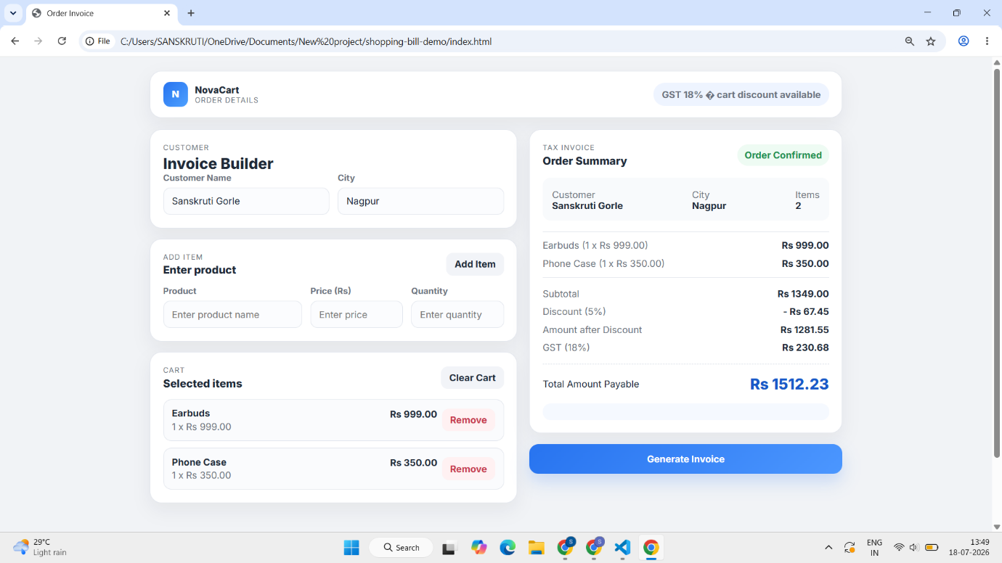
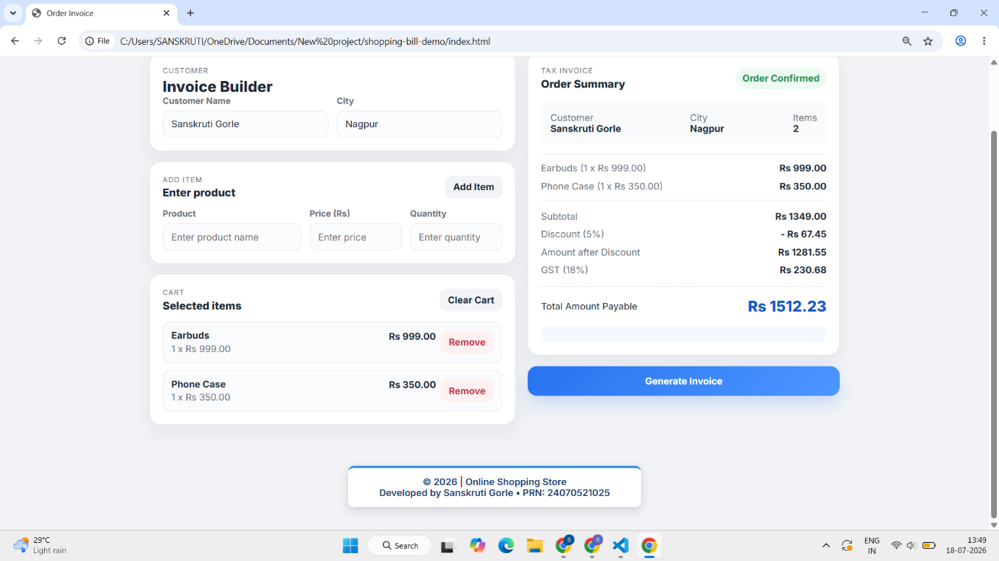

Conclusion –
The experiment was successfully performed to understand JavaScript variables, data types, template literals, and destructuring. These concepts were applied to develop an online shopping billing calculator that accepts user input and generates the final invoice dynamically.

